Docker-Challenge-01

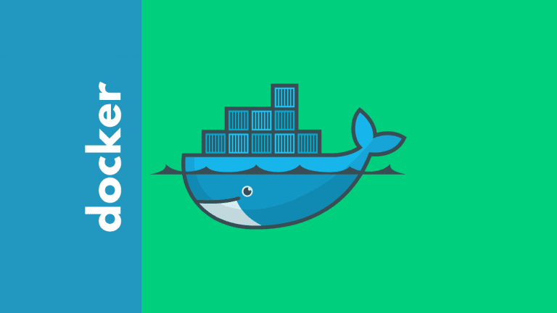

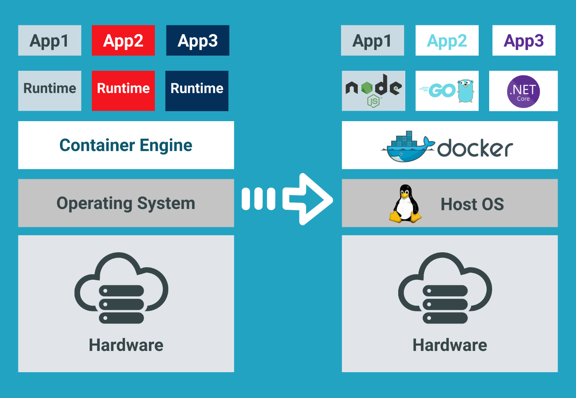

Task Title
Docker-Challenge-01
Objective
The objective of this task is to execute the Docker-Challenge tasks posted on slack and worked on executing them as per requirement.
Prerequisites
List all requirements before starting:
- Dockerfile
- DockerHub
- Docker Image
- Amazon ECR
- EC2 instance using Terraform and install Jenkins
- Jenkins job to build and push Docker Image to DockerHub (Source: https://github.com/betawins/Python-app.git)
- frontend source code (Source Codes: https://github.com/betawins/docker-tasks.git)
- Java-based source code (Source Codes: https://github.com/betawins/docker-tasks.git)
- Node.js-based source code (Source Codes: https://github.com/betawins/docker-tasks.git)
- docker-compose file

Issues Faced: Briefly mention issues and how you fixed them. Posted below in the last.
Conclusion
Conclusion has been provided for every task at the end.

Challenges

Task 1 - Create a customized Docker image using a Dockerfile.
Objective:
Creating a custom Docker image with a Dockerfile is a core DevOps skill.
We define the base OS/app, copy our code, install packages, and tell Docker how to run it.

Step by step Implementation
Step 1: Launch an ec2-server where Docker is installed
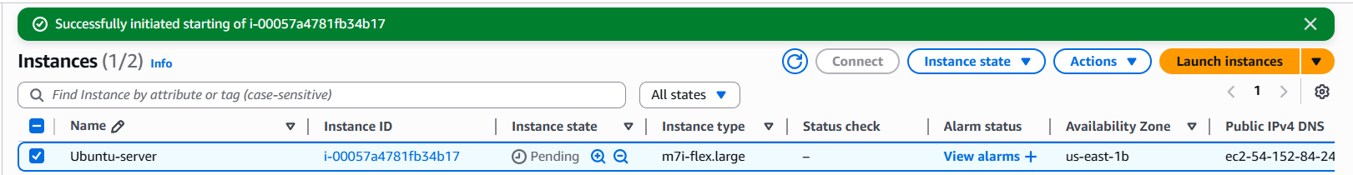

Step 2: Build an image that:
- Uses NGINX
- Serves a custom index.html
- Runs on port 80
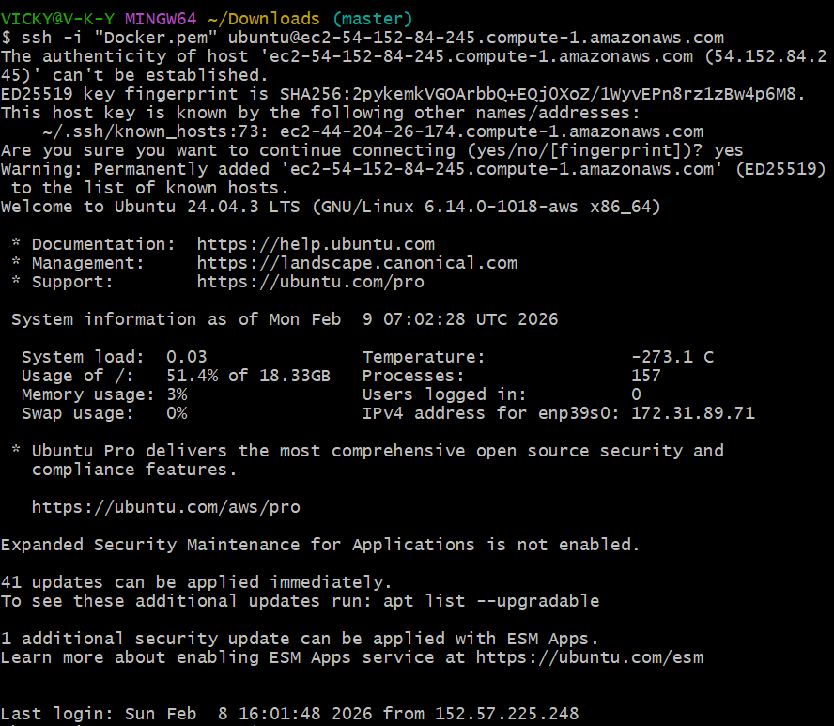

Docker pull nginx:latest
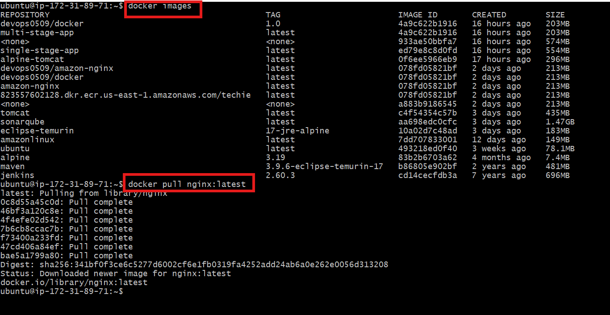
Vi dockerfile
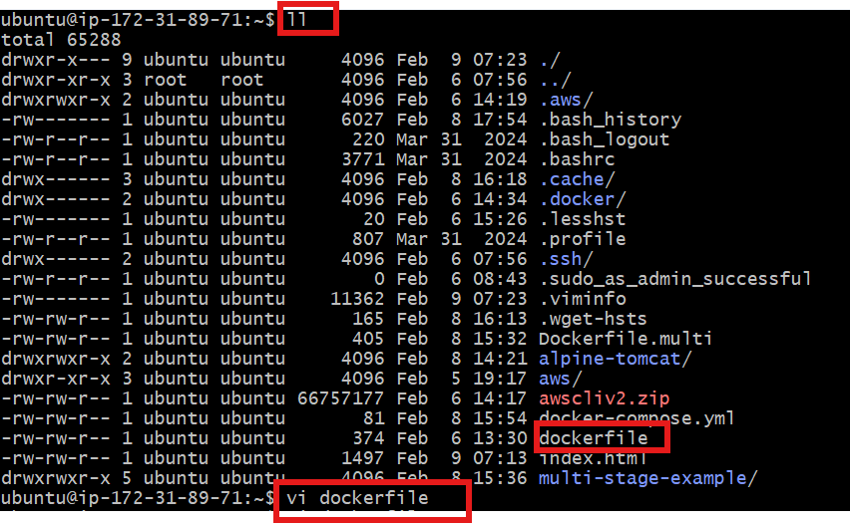
Updated dockerfile to customize my image
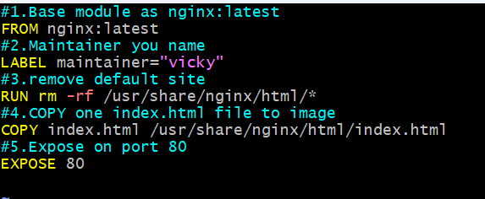

Build and Run
docker build -t myweb:v3 .
docker run -d -p 8080:80 --name mysite myweb:v3
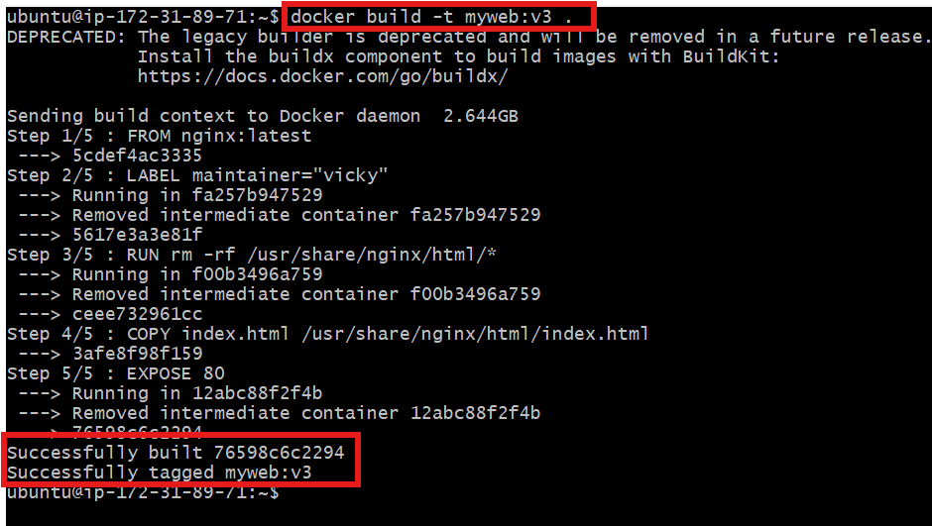

Validation:
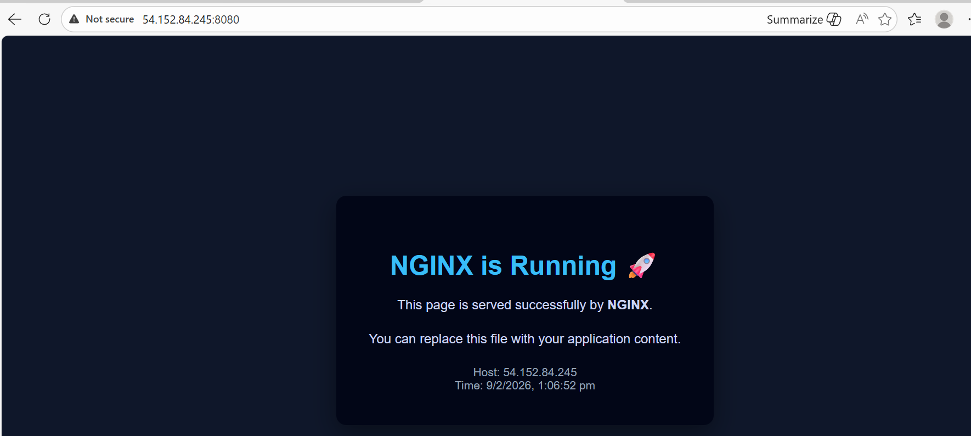

Conclusion:
In this task, we created a customized Docker image using a Dockerfile based on NGINX.
The default web content inside the image was removed and replaced with our own index.html.
After building the image and running the container, the application was successfully accessible from the browser, proving that the custom image works as expected.
This process demonstrates how Docker enables consistent, portable, and repeatable deployments across environments.

Task 2 - Push the image to Docker Hub.
Objective: What we need before push
Docker Hub account
Image built locally (example: myweb:v3)
Docker login done

Step by step Implementation:
Step 1: Login Docker
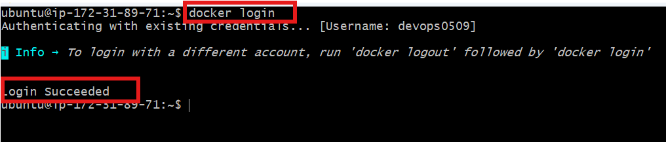

Step 2: Tag the Image
docker tag myweb:v3 devops0509/myweb:v3
docker push devops0509/myweb:v3
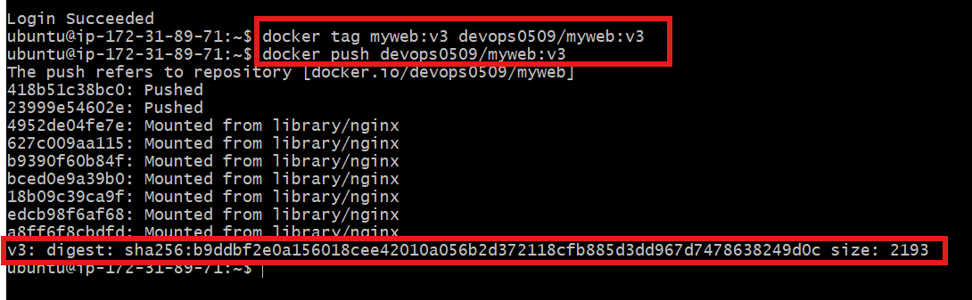

Step 3: Navigate to DockerHub and verify if myweb image is present
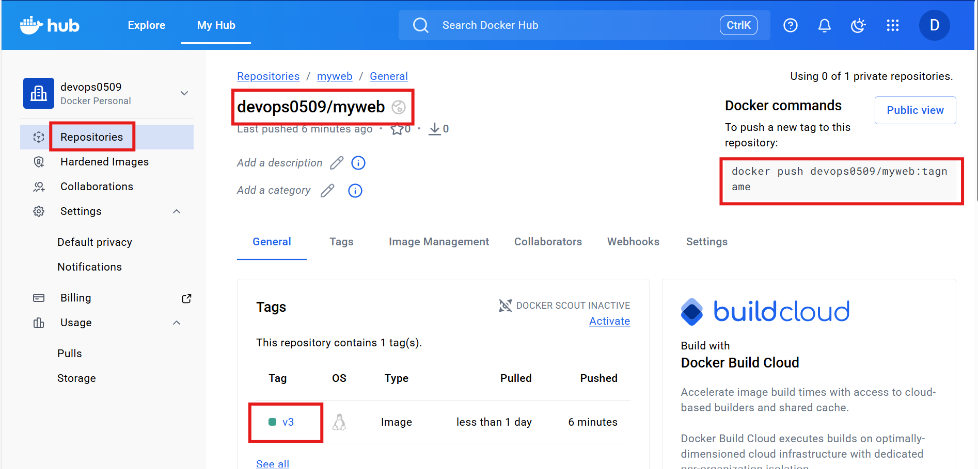

Success and task completed
Task 3 - Push the same image to Amazon ECR.
Objective: What you need
- AWS account
- AWS CLI configured (aws configure)
- Docker image built locally (example: myweb:v3)
- Permission to push to ECR

Step by step Implementation
Step 1:
Create repo → Login → Tag → Push → Verify
Repo created……..myweb
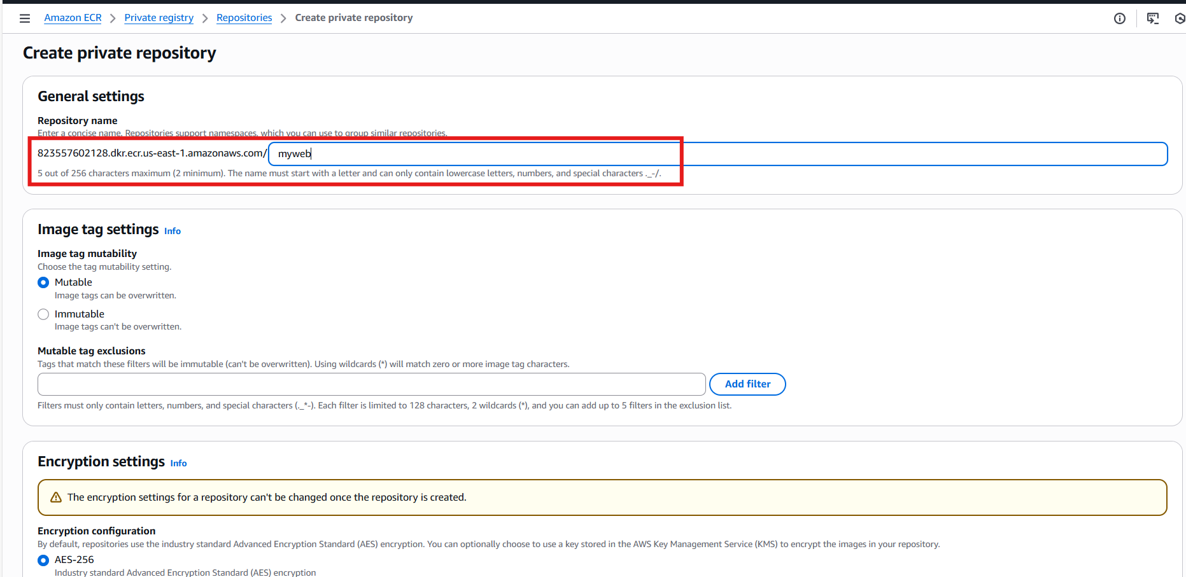

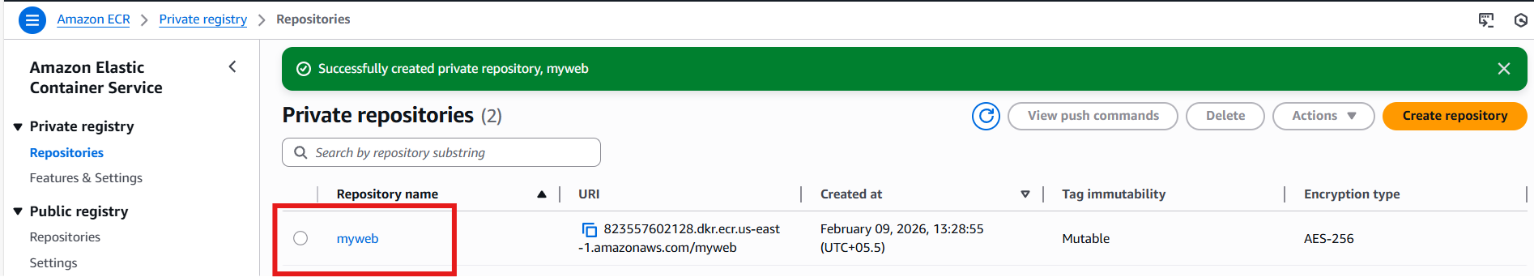

Login using command- aws ecr get-login-password --region us-east-1 | \ docker login --username AWS --password-stdin 823557602128.dkr.ecr.us-east-1.amazonaws.com

Tag the image to aws ecr- docker tag myweb:v3 823557602128.dkr.ecr.us-east-1.amazonaws.com/myweb:v3

Let’s push the image to ecr
docker push 823557602128.dkr.ecr.us-east-1.amazonaws.com/myweb:v3
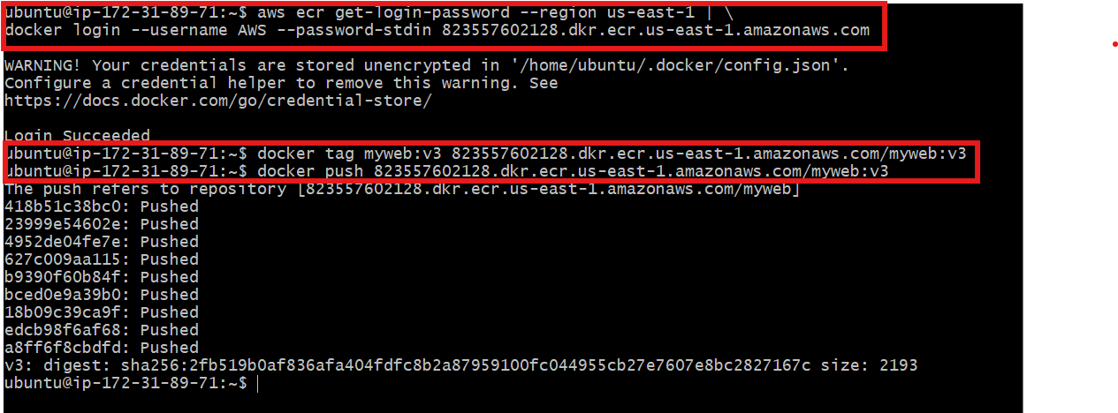

Validation:
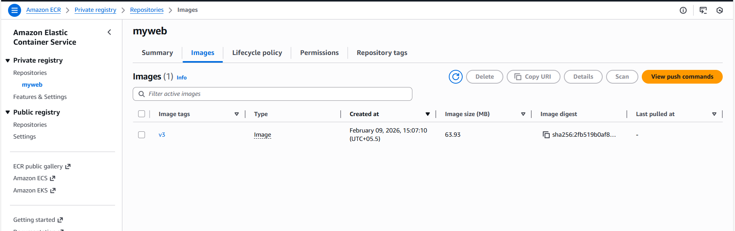

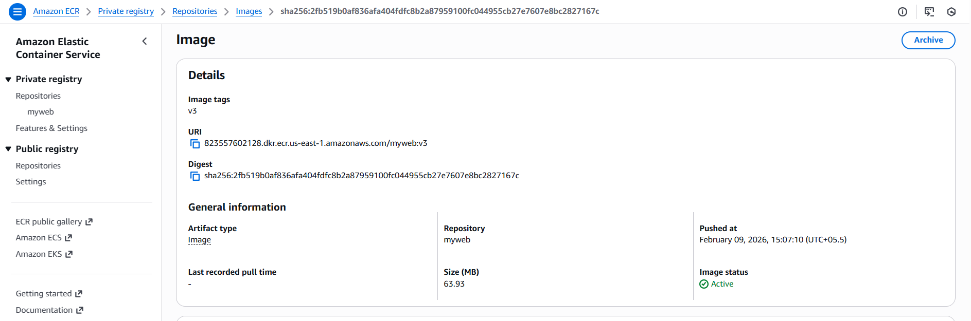

Task 4 - Provision one EC2 instance using Terraform and install Jenkins.
Objective: What this will do
Terraform will:
create EC2
open ports 22 & 8080
install Java
install Jenkins
start service
After apply → open browser → Jenkins ready

Step by step Implementation
Step 1: Project Structure
jenkins-terraform/
├── main.tf
├── variables.tf
└── outputs.tf

Step 2: Variables.tf
variable "region" {
default = "us-east-1"
}

variable "instance_type" {
default = "t2.micro"
}

variable "key_name" {
description = "Docker"
}

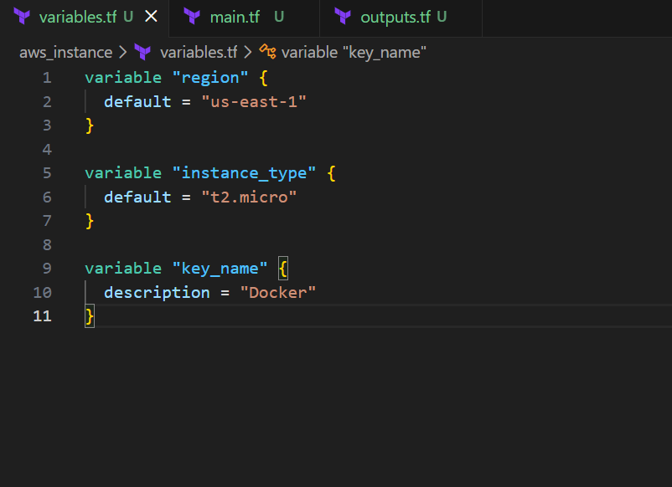
Step 3: Main.tf
provider "aws" {
region = var.region
}

# Security group
resource "aws_security_group" "jenkins_sg" {
name = "jenkins-sg"

ingress {
description = "SSH"
from_port = 22
to_port = 22
protocol = "tcp"
cidr_blocks = ["0.0.0.0/0"]
}

ingress {
description = "Jenkins"
from_port = 8080
to_port = 8080
protocol = "tcp"
cidr_blocks = ["0.0.0.0/0"]
}

egress {
from_port = 0
to_port = 0
protocol = "-1"
cidr_blocks = ["0.0.0.0/0"]
}
}

# Latest Amazon Linux
data "aws_ami" "amazon_linux" {
most_recent = true
owners = ["amazon"]

filter {
name = "name"
values = ["al2023-ami-*-x86_64"]
}
}

# EC2 instance
resource "aws_instance" "jenkins" {
ami = data.aws_ami.amazon_linux.id
instance_type = var.instance_type
key_name = var.key_name
vpc_security_group_ids = [aws_security_group.jenkins_sg.id]

user_data = <<-EOF
#!/bin/bash
yum update -y

# Install Java
yum install -y java-17-amazon-corretto

# Add Jenkins repo
wget -O /etc/yum.repos.d/jenkins.repo \
https://pkg.jenkins.io/redhat-stable/jenkins.repo

rpm --import https://pkg.jenkins.io/redhat-stable/jenkins.io-2023.key

# Install Jenkins
yum install -y jenkins

systemctl enable jenkins
systemctl start jenkins
EOF

tags = {
Name = "jenkins-server"
}
}

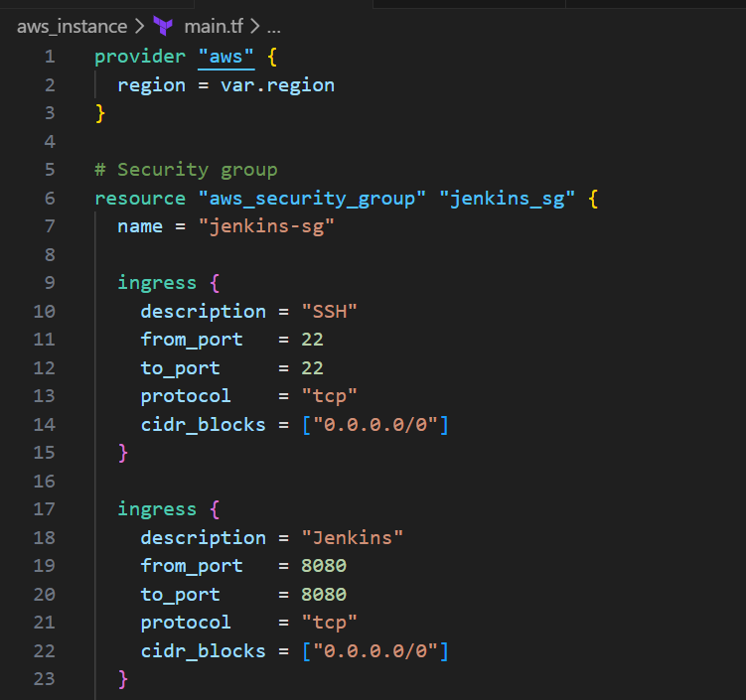
Step 4: Outputs.tf
output "jenkins_public_ip" {
value = aws_instance.jenkins.public_ip
}
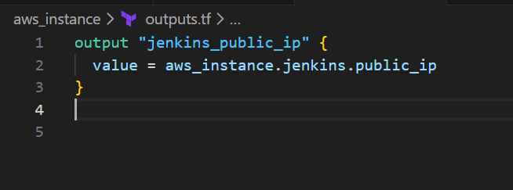

Terraform init
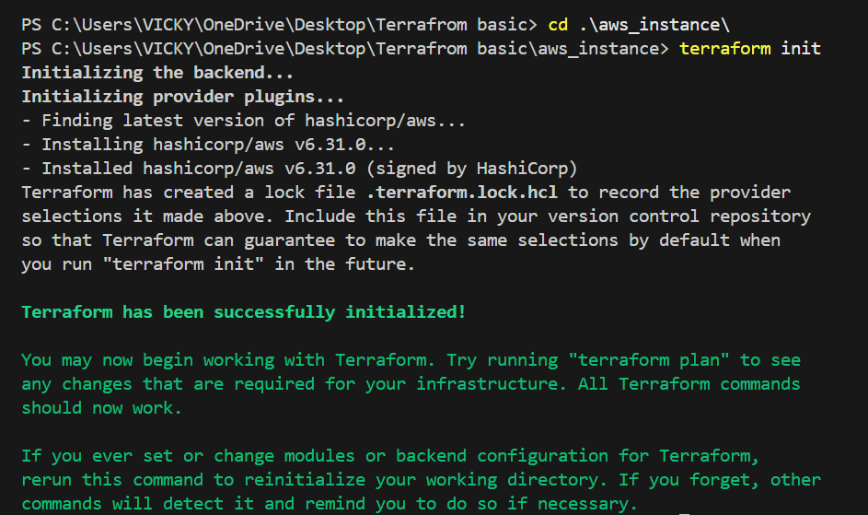

Aws configure
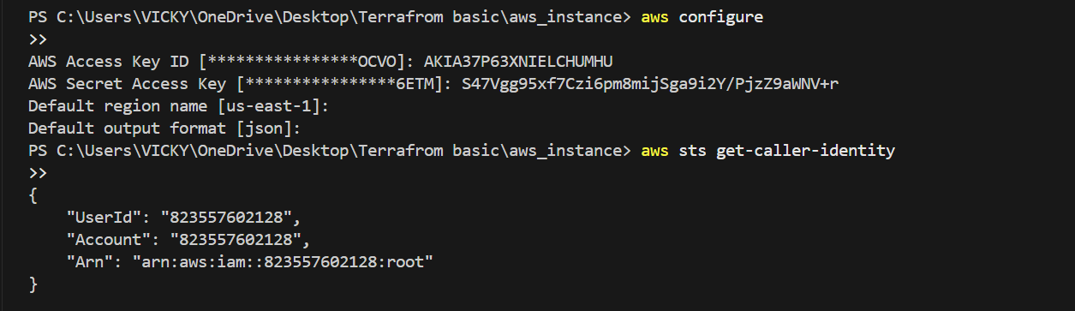

Terraform plan
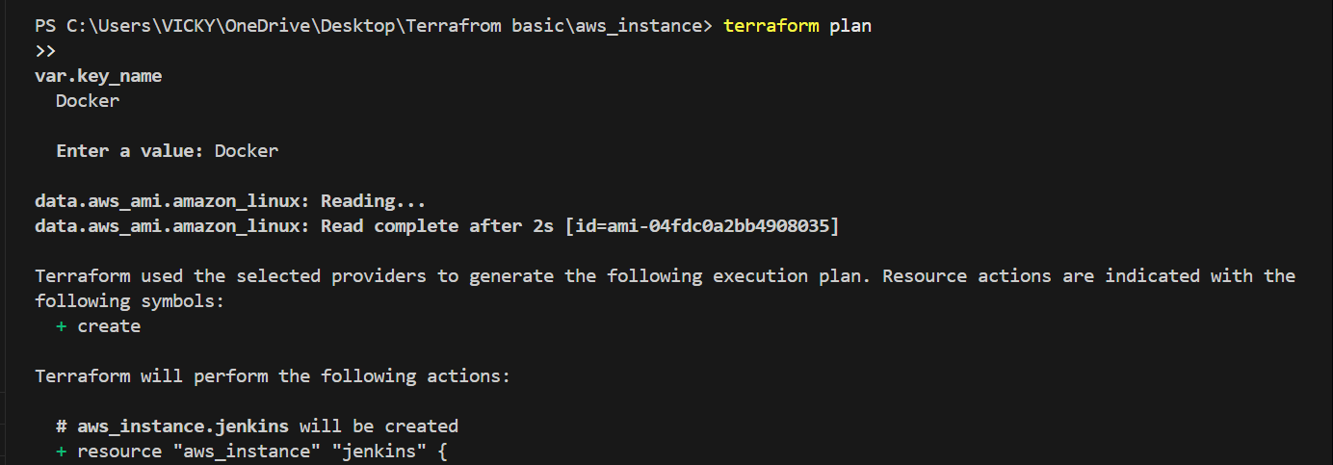

Terraform apply
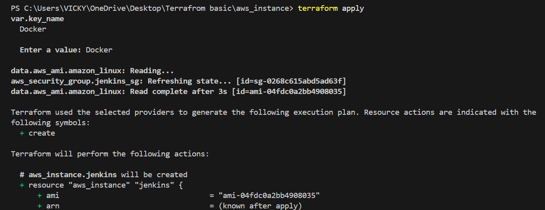
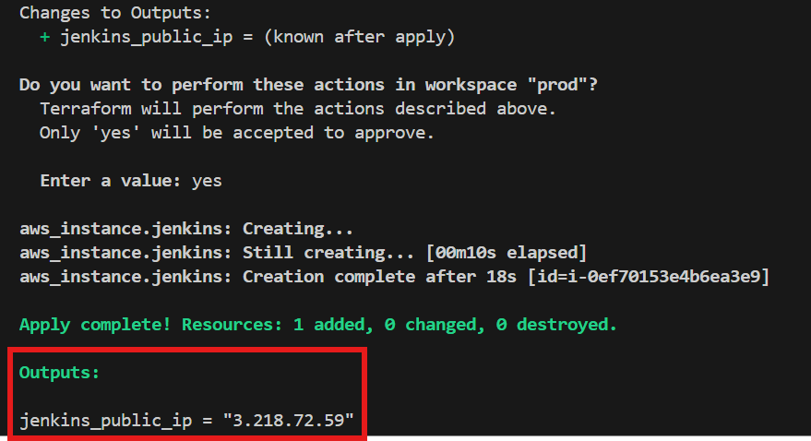

Let’s verify if Jenkins server is launched
Success- Jenkins-server is launched as expected
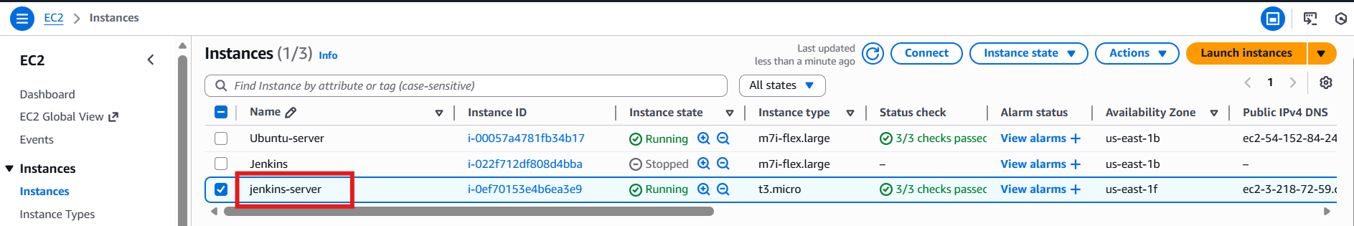

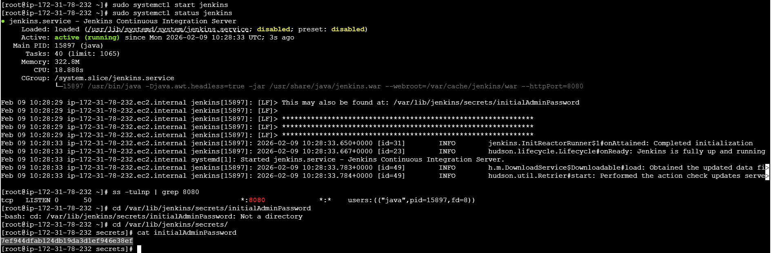

Validation:
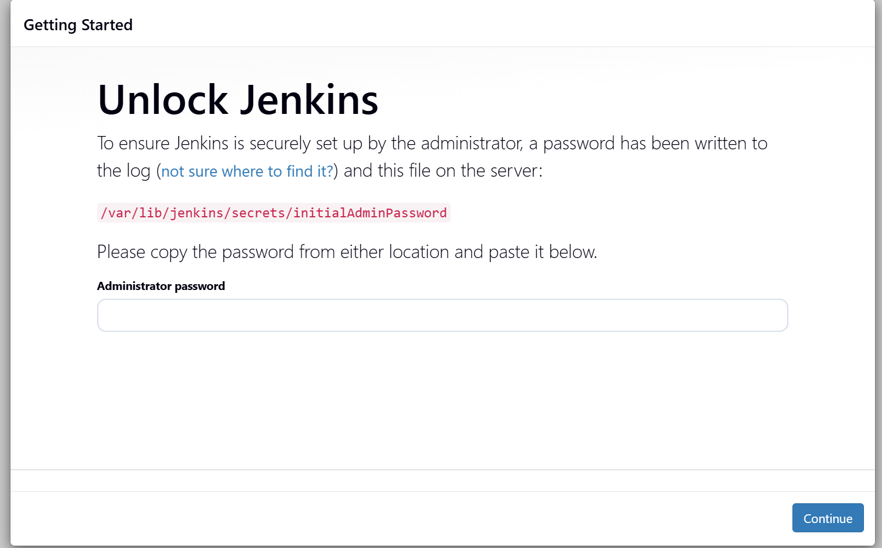

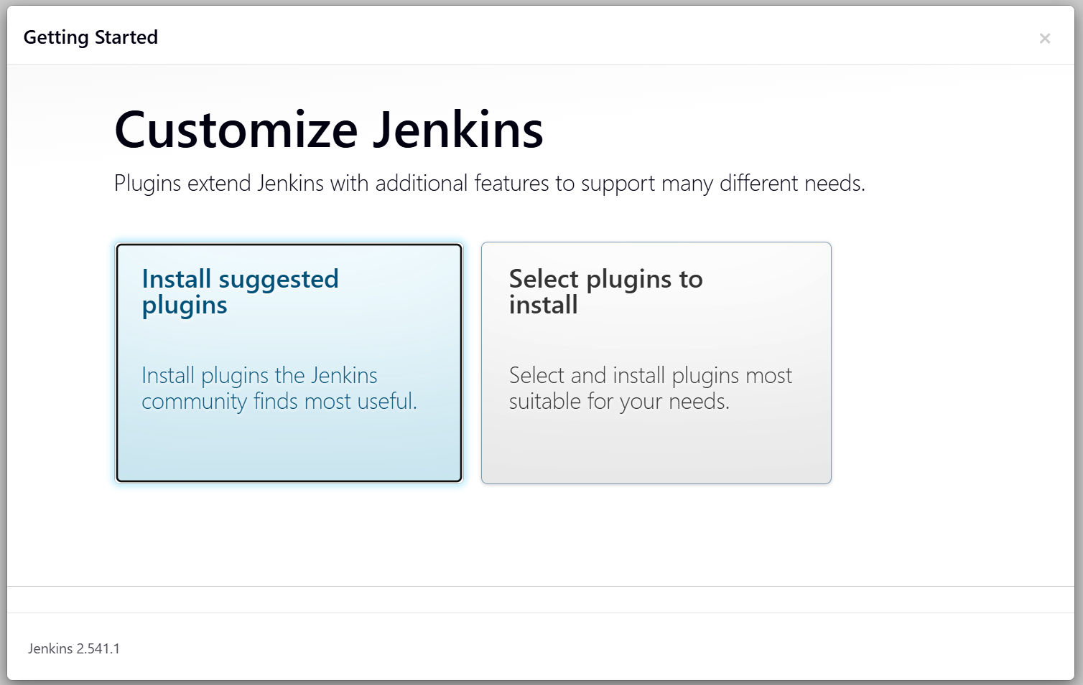

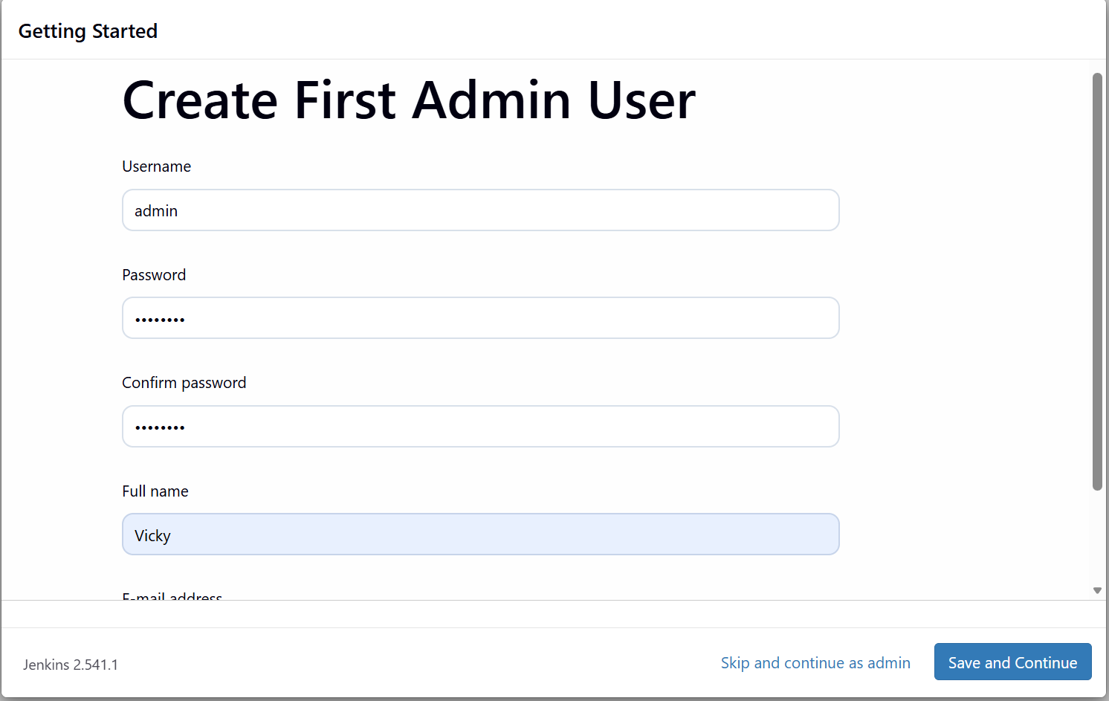

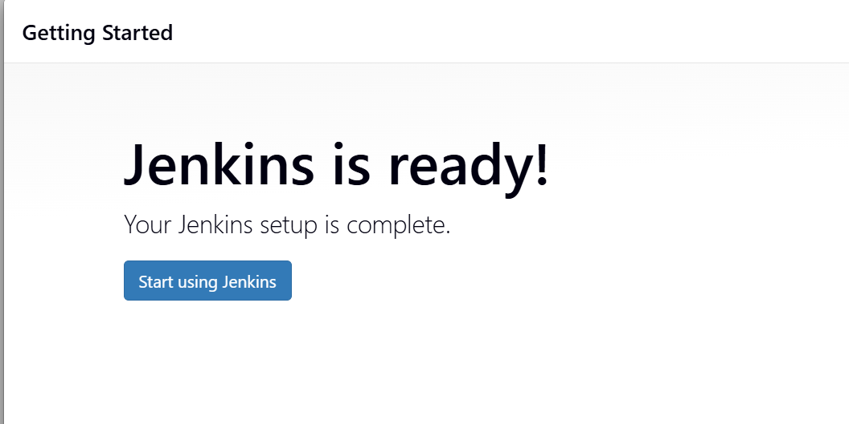

Task 5 - Create one Jenkins job to build and push the Docker image to Docker Hub.
Source: https://github.com/betawins/Python-app.git

Objective: Use Jenkins to:
Pull code from GitHub
Build Docker image
Push to Docker Hub
Step by step Implementation
Step 1: Architecture
GitHub → Jenkins → Docker build → Docker Hub

Step 2: Install Required Jenkins Plugins
In Jenkins UI:
Manage Jenkins → Plugins → Available →
Install:
✔ Git
✔ Pipeline
✔ Docker Pipeline
Restart Jenkins.

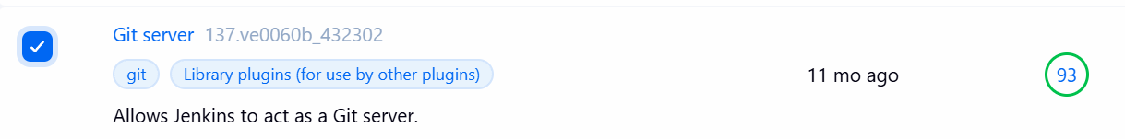

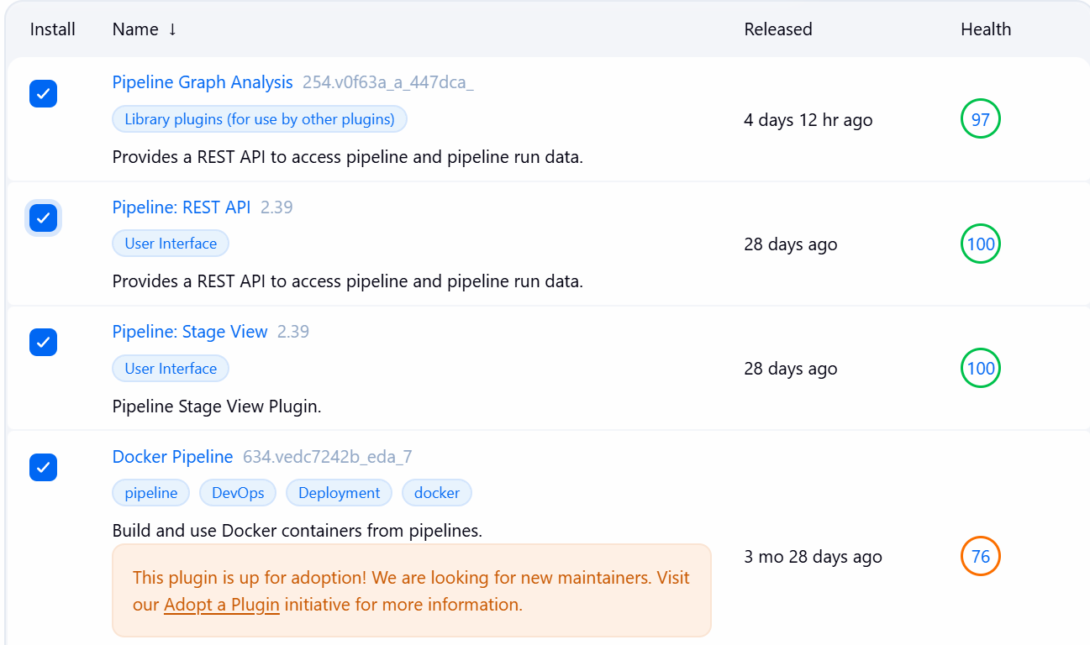

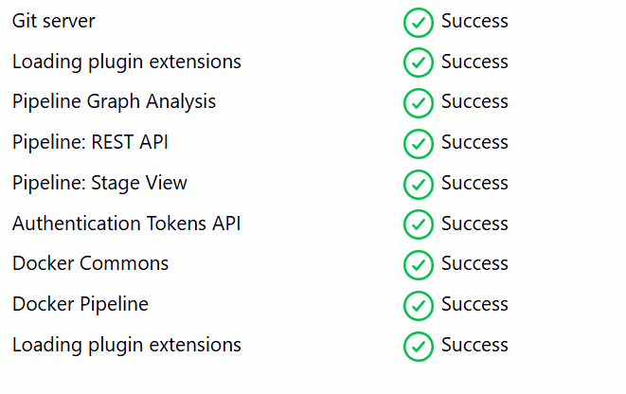

Jenkins restarted
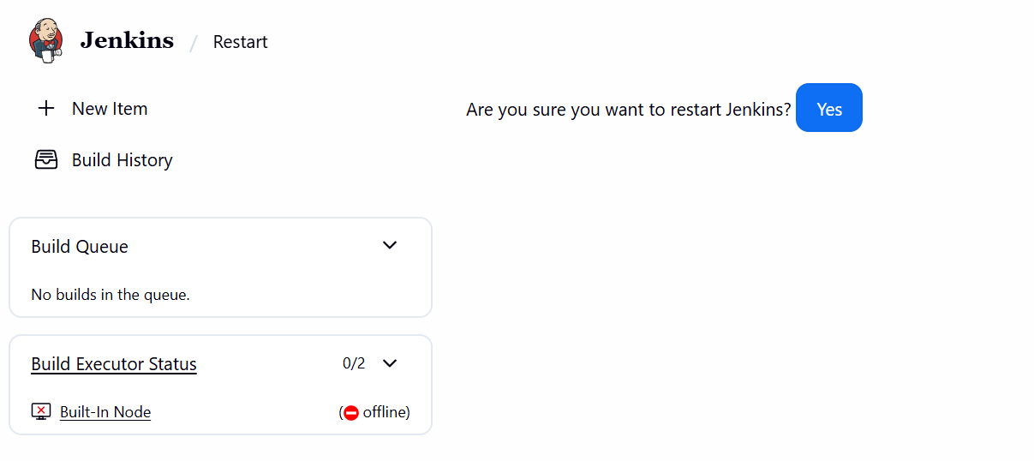

Step 3 – Add Docker Hub Credentials
Manage Jenkins → Credentials → Global → Add credentials

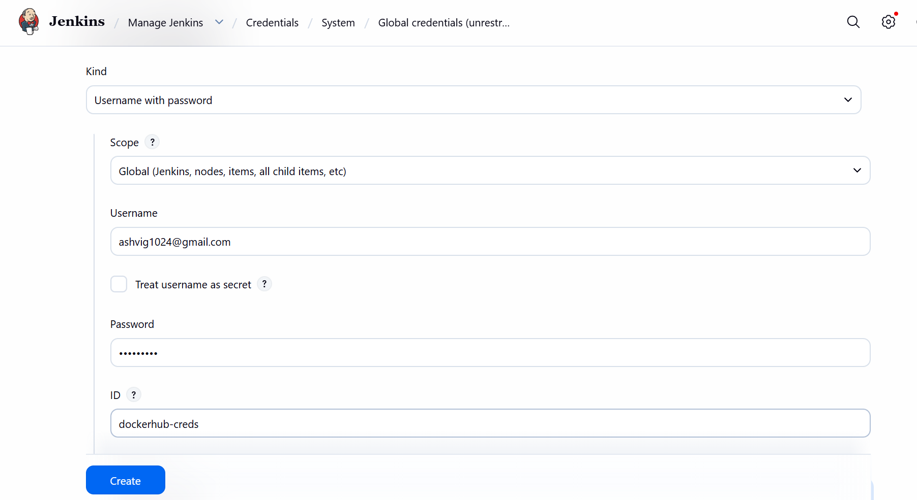

Step 4 – Create Pipeline Job
New Item → Name: python-docker-build

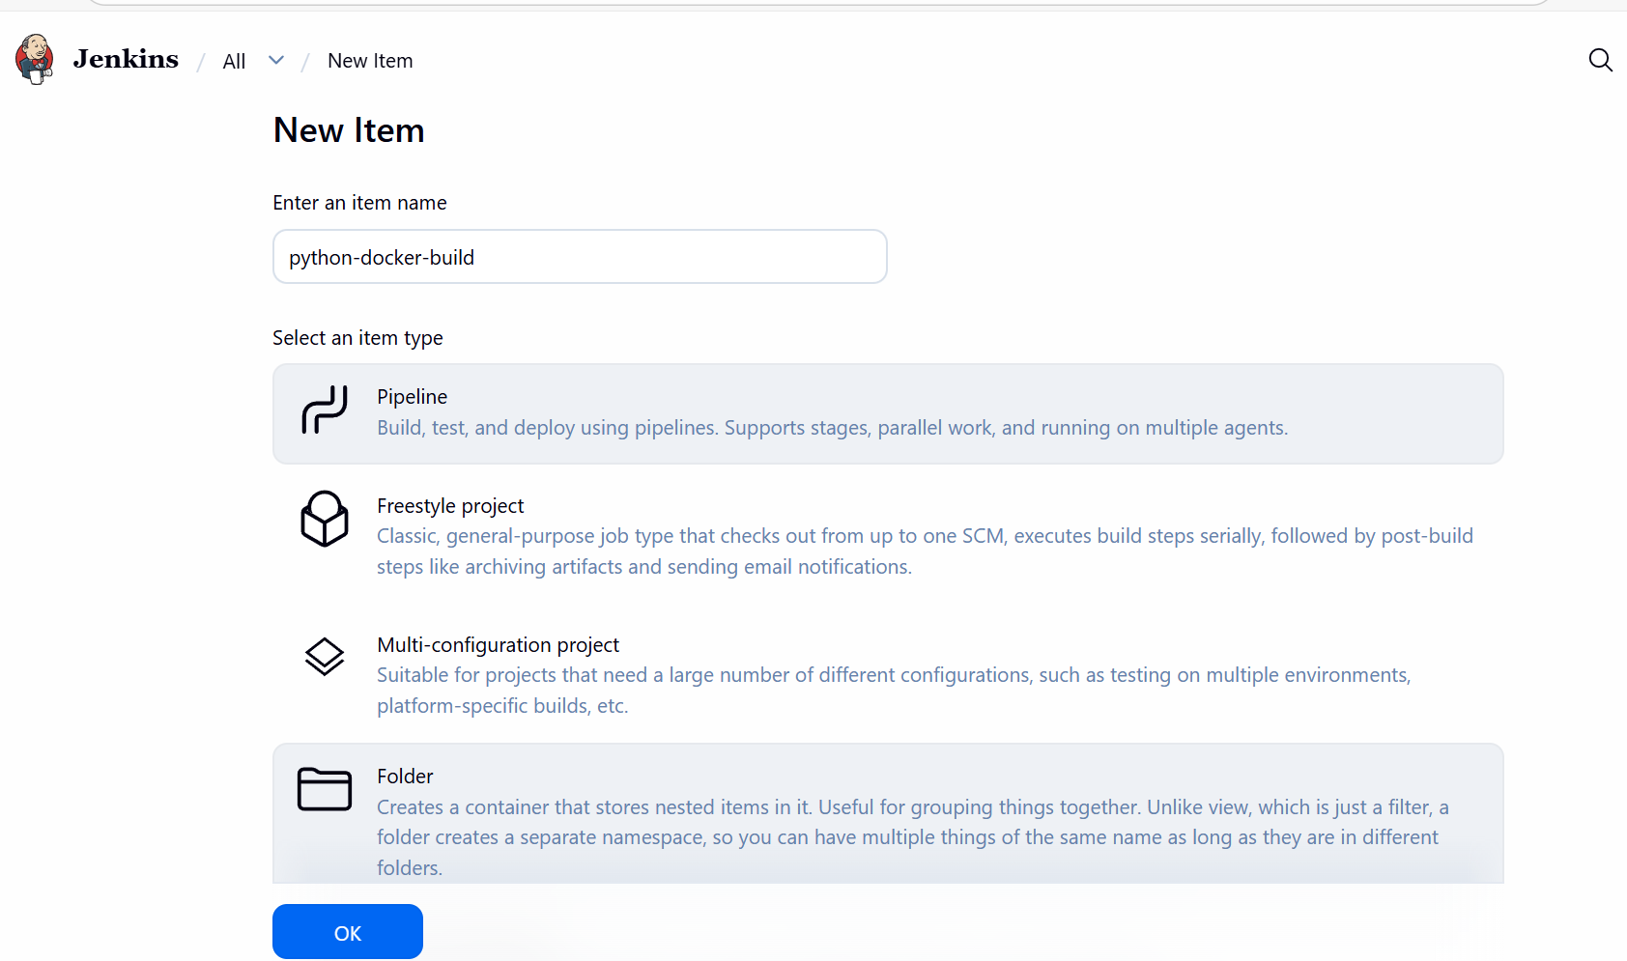

Step 5 – Add Pipeline Script
In job → Pipeline → Definition → Pipeline script

pipeline {
agent any

environment {
IMAGE_NAME = "devops0509/python-app"
TAG = "v1"
}

stages {

stage('Checkout Code') {
steps {
git branch: 'main', url: 'https://github.com/betawins/Python-app.git'
}
}

stage('Build Image') {
steps {
sh 'docker build -t $IMAGE_NAME:$TAG .'
}
}

stage('Login to DockerHub') {
steps {
withCredentials([usernamePassword(
credentialsId: 'dockerhub-creds',
usernameVariable: 'USER',
passwordVariable: 'PASS'
)]) {
sh 'echo $PASS | docker login -u $USER --password-stdin'
}
}
}

stage('Push Image') {
steps {
sh 'docker push $IMAGE_NAME:$TAG'
}
}
}
Install git in the Jenkins server to pull the repo from GitHub
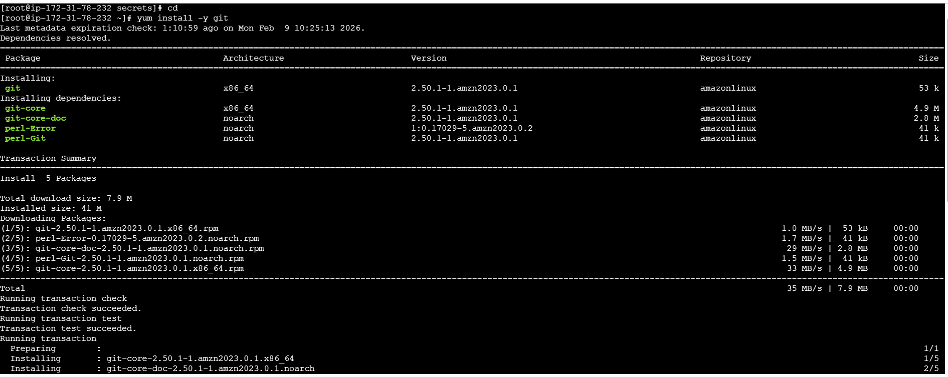

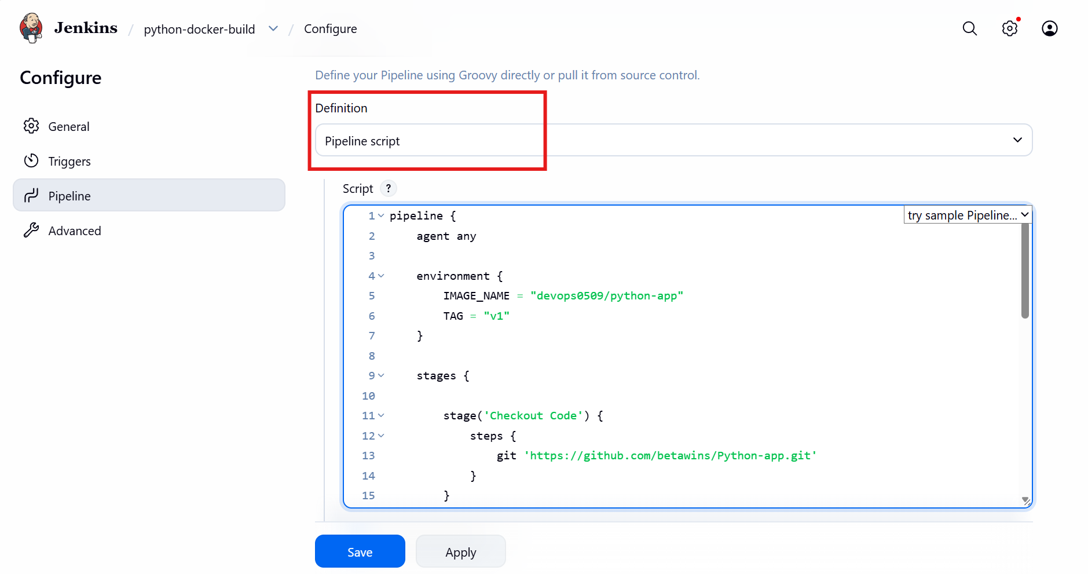

Build Now

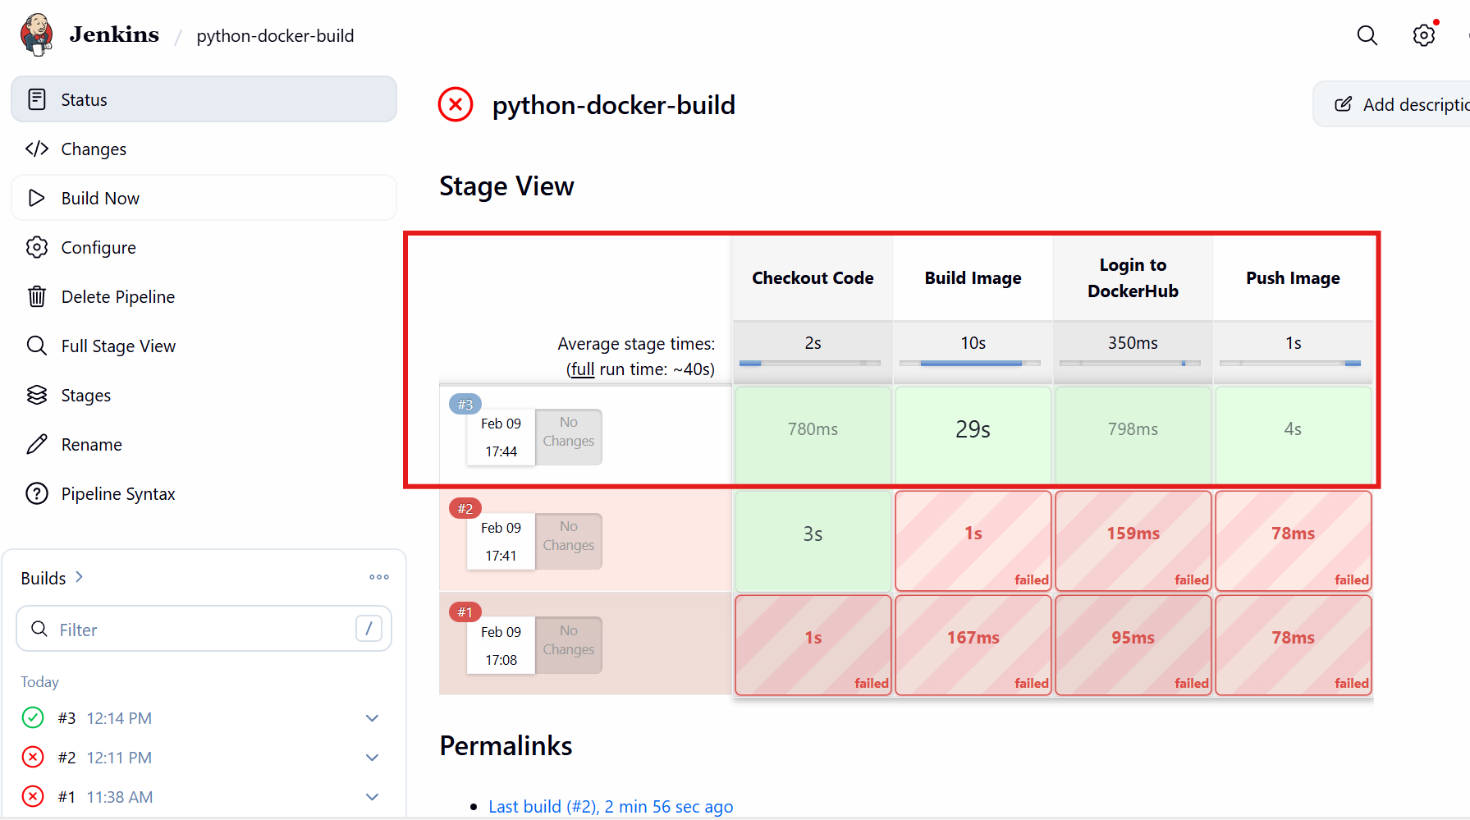

Issue faced:
Add Jenkins to docker group- sudo usermod -aG docker jenkins
Restart Jenkins- sudo systemctl restart jenkins
Verify- groups jenkins

Validation:
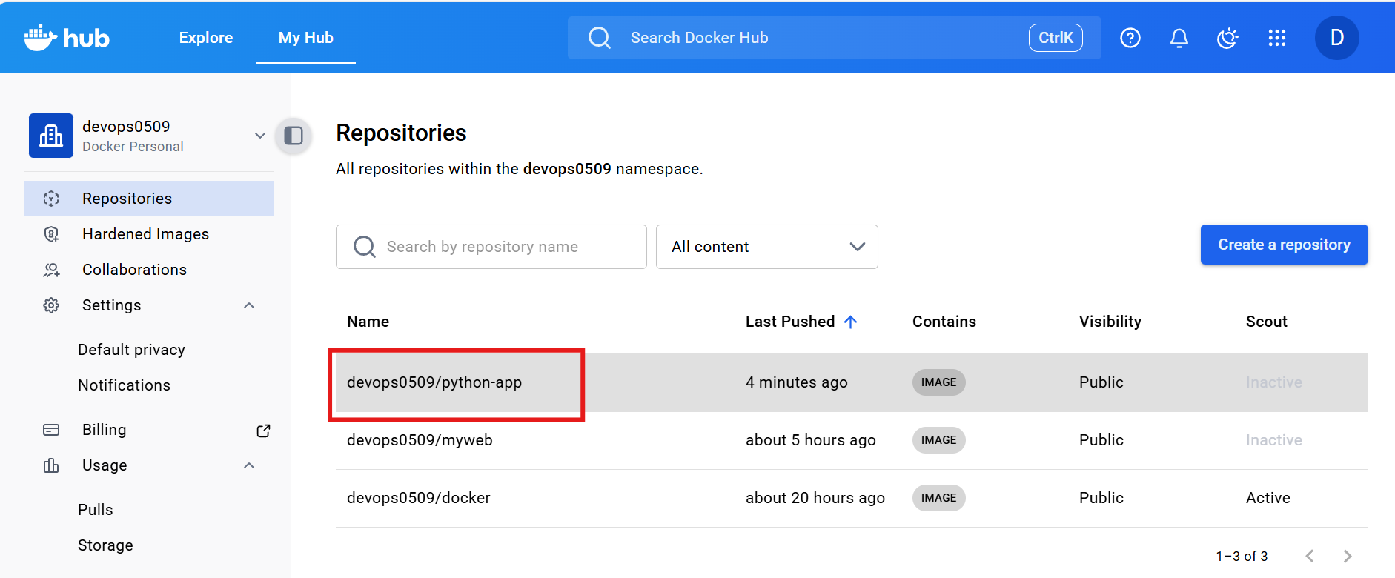

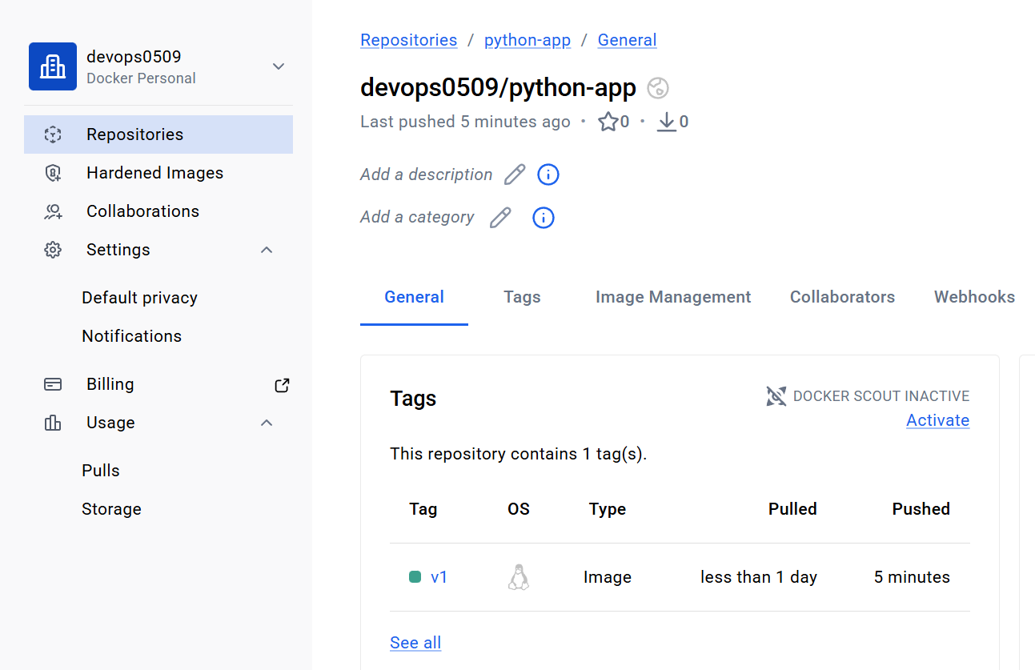

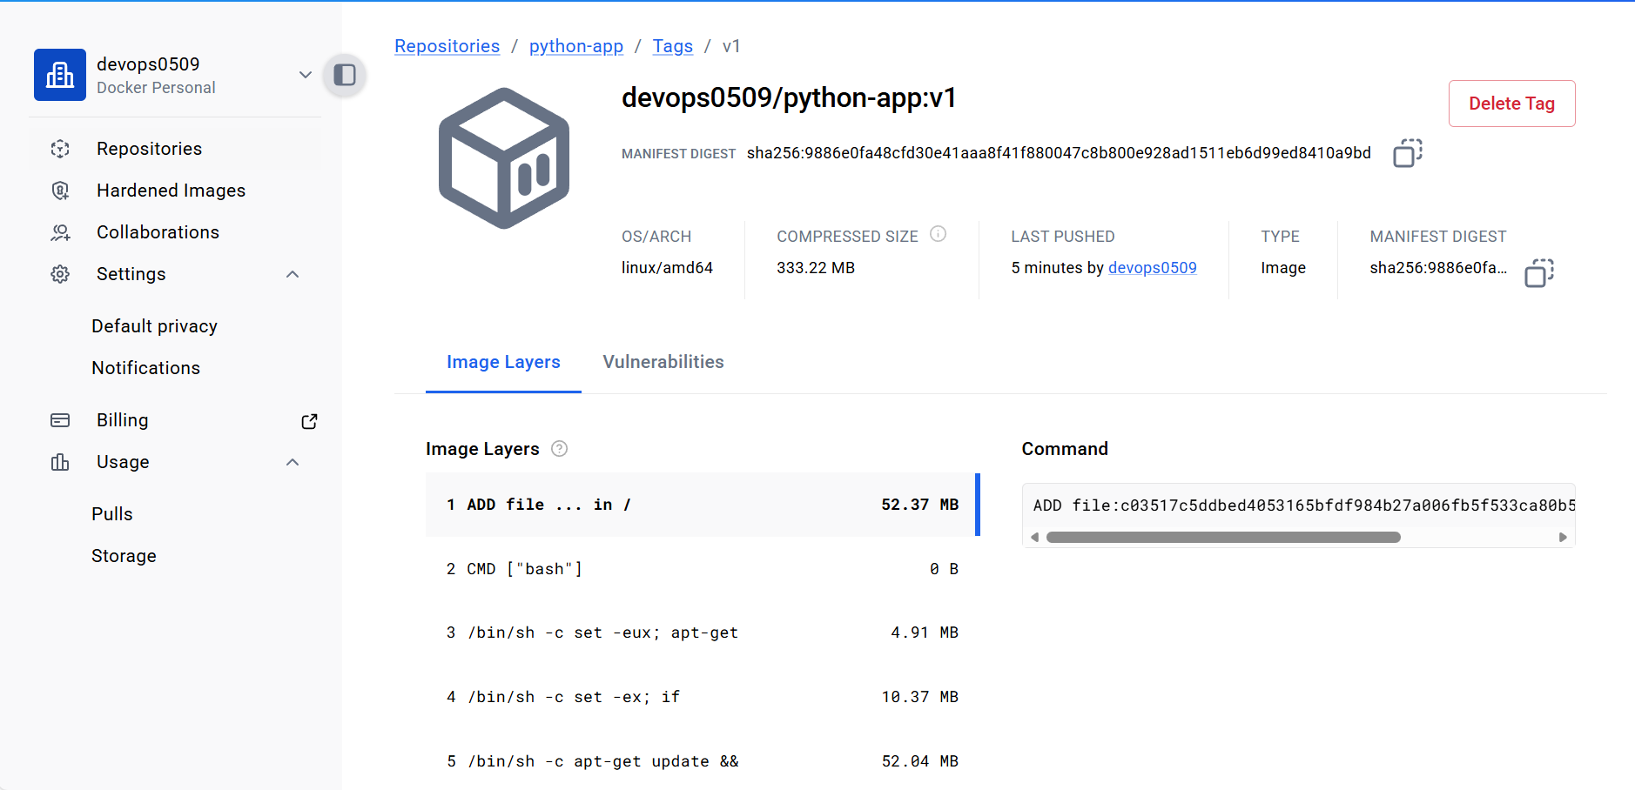

Source Codes: https://github.com/betawins/docker-tasks.git
Task 6 - From the frontend source code, write a Dockerfile, build a Docker image, run it, and push that image to your Docker registry.

Objective: we need to:
- take frontend code
- write Dockerfile
- build image
- run container
- push to registry

Step by step Implementation
Step 1 – Clone repository
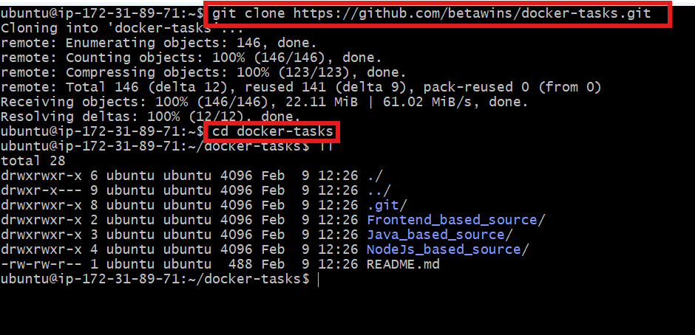

Step 2 – Create Dockerfile
Vi Dockerfile
#1. Base module as nginx:latest
FROM nginx:latest

#2. Maintainer your name
LABEL maintainer=“vicky”

3#. remove default content
RUN rm -rf /usr/share/nginx/html/*

4#. copy one index.html file to image
COPY index.html /usr/share/nginx/html/index.html

5#. Expose on port 80
EXPOSE 80

CMD ["nginx", "-g", "daemon off;"]
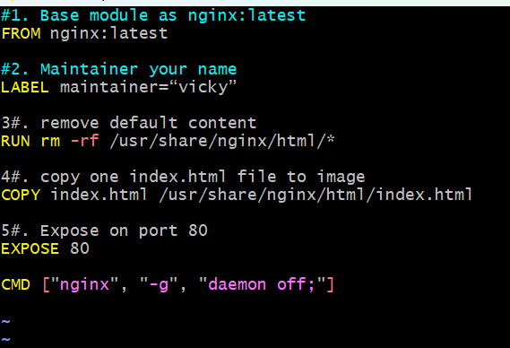

Step 3 – Build image
docker build -t devops0509/frontend:v1 .
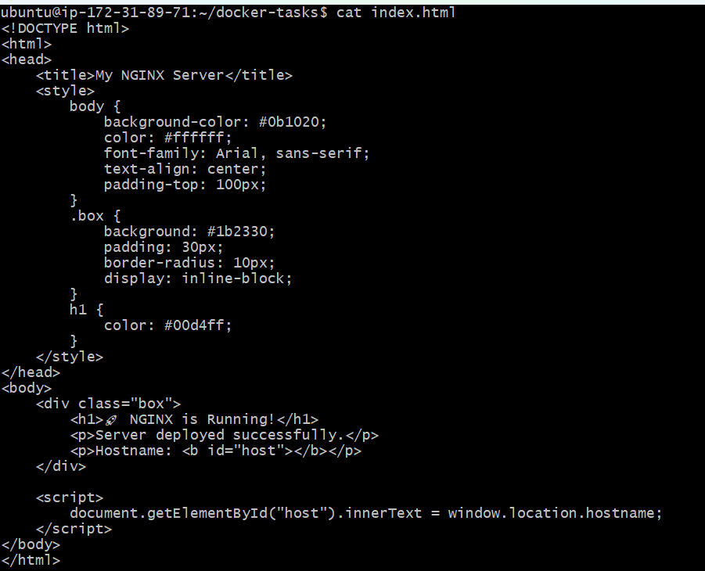
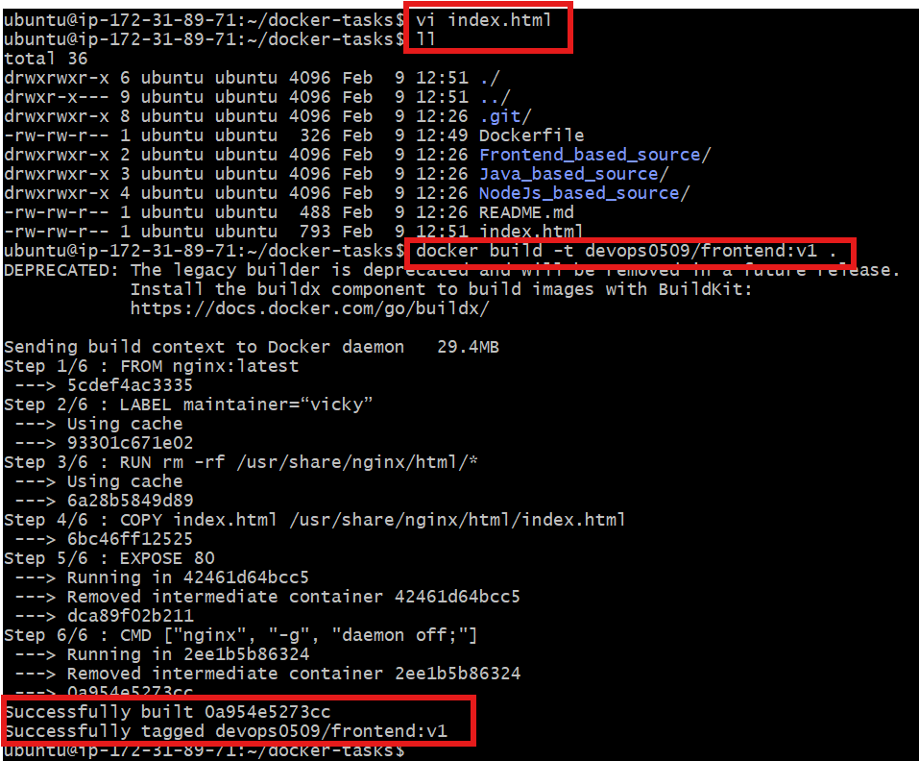

Step 4 – Run container
docker run -d -p 8089:80 devops0509/frontend:v1

Step 5 – Verify
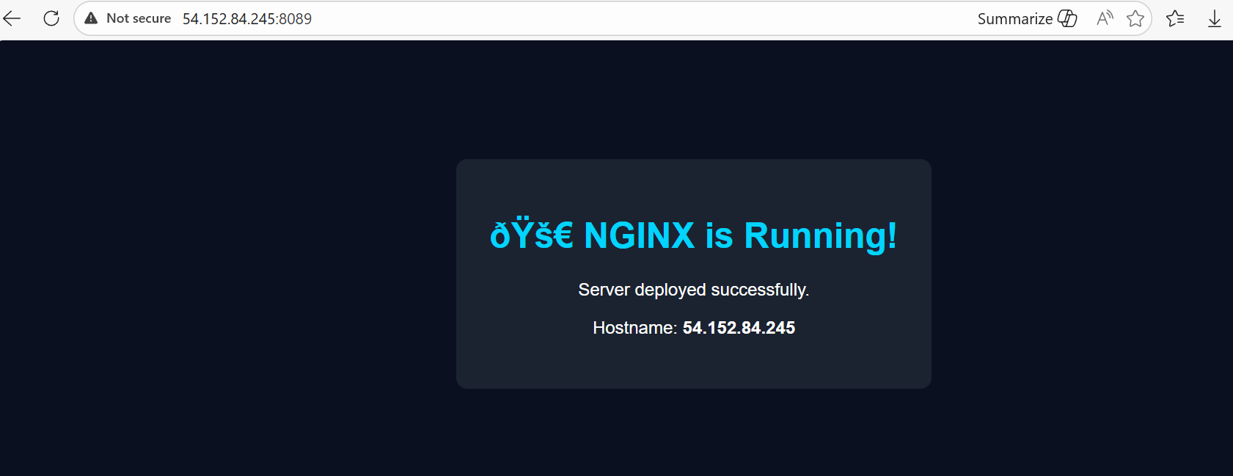
Step 6 – Login to Docker Hub
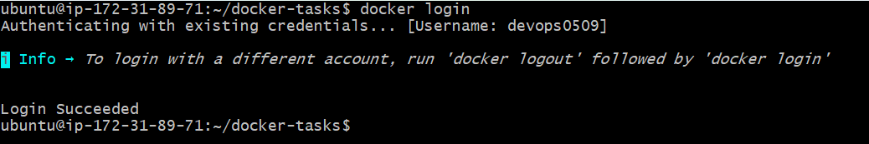

Step 7 – Push image
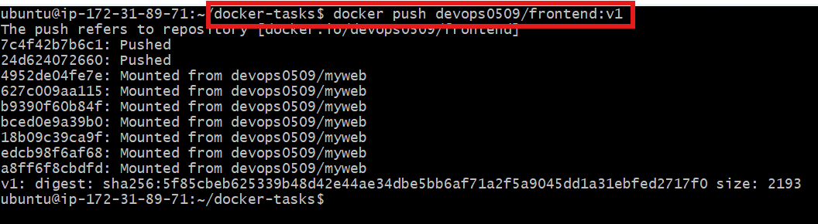

Task completed

Task 7 - From the Java-based source code, write a Dockerfile, build, run, and push the image to the Docker registry.

Objective: we need to
- write Dockerfile
- build image
- run container
- push to Docker Hub

Step by step Implementation
Step 1: First understand the requirement
Java usually refers to pom.xml

So we build a JAR/WAR → run inside container.

Step 2: Clone the repo
git clone https://github.com/betawins/docker-tasks.git
cd docker-tasks

Step 3: Go inside Java folder
This is where pom.xml file will be present
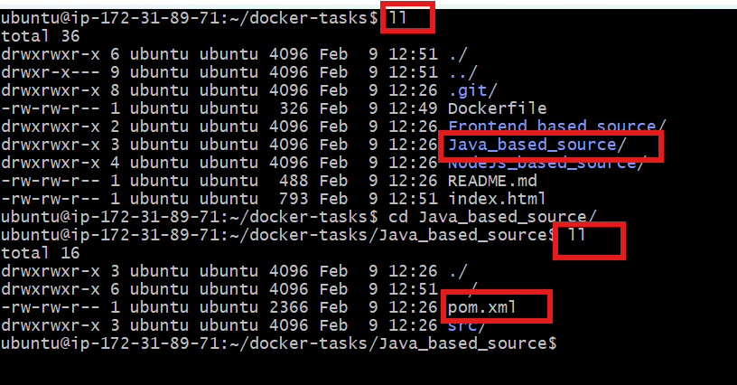

Step 4 – Create Dockerfile
Vi Dockerfile
# ---------- Stage 1: Build ----------
FROM maven:3.9-eclipse-temurin-17 AS build

WORKDIR /app
COPY pom.xml .
RUN mvn -B -q dependency:go-offline

COPY src ./src
RUN mvn clean package -DskipTests

# ---------- Stage 2: Run ----------
FROM eclipse-temurin:17-jre

WORKDIR /app

COPY --from=build /app/target/*.jar app.jar

EXPOSE 8080

ENTRYPOINT ["java", "-jar", "app.jar"]

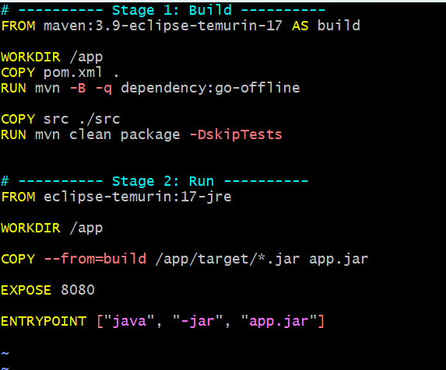

Step 5 – Build image
docker build -t devops0509/java-app:v1 .
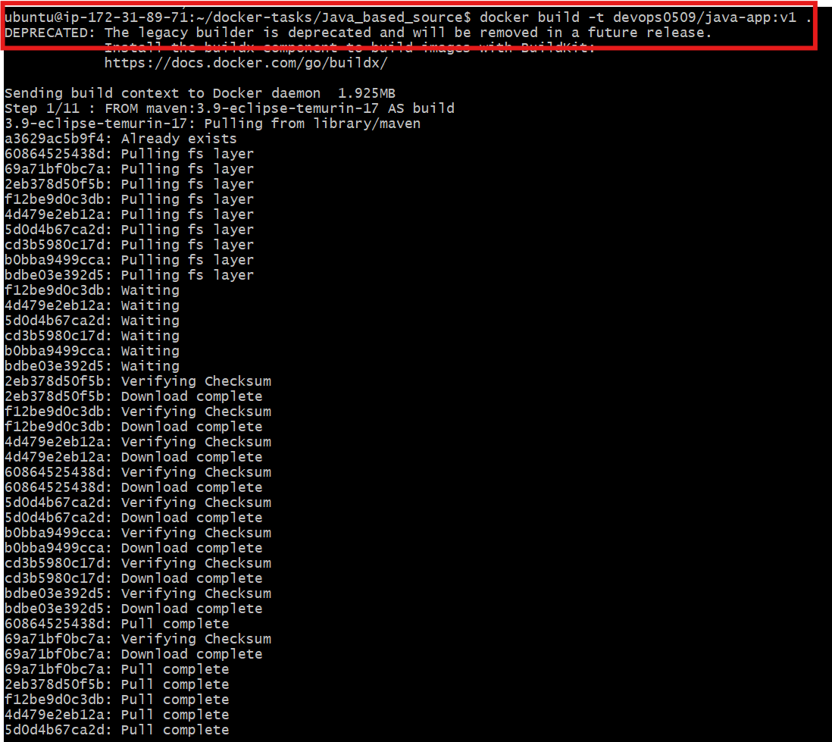
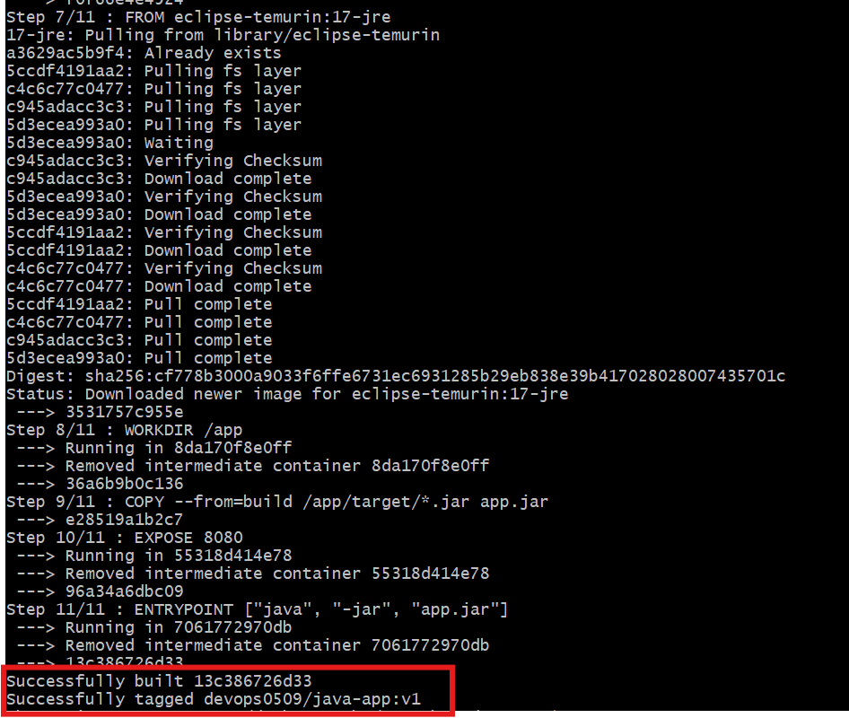

Step 6: Run container
docker run -d -p 8088:8080 devops0509/java-app:v1

Step 7: Update security groups to allow 8088
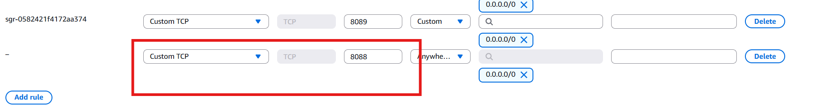

Step 8: Verify in browser
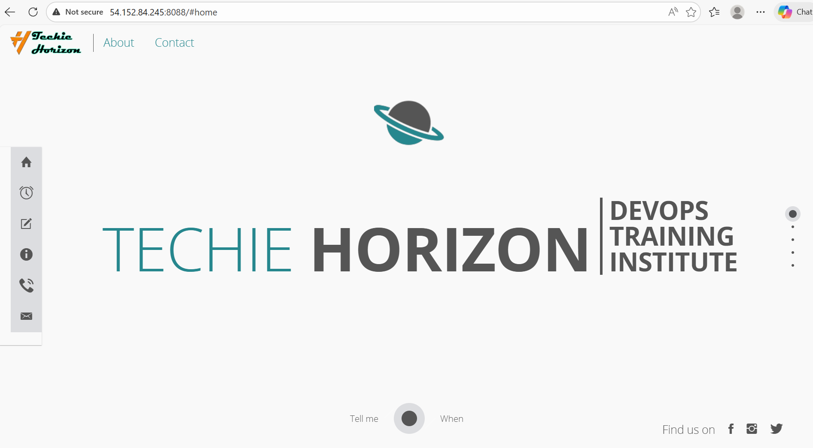


Task 8 - From the Node.js-based source code, write a Dockerfile, build with tag v1, run, and push it to the Docker registry.

Objective: we will
- write Dockerfile
- build image with tag v1
- run container
- push to Docker Hub

Step by step Implementation:
Step 1: Clone repo
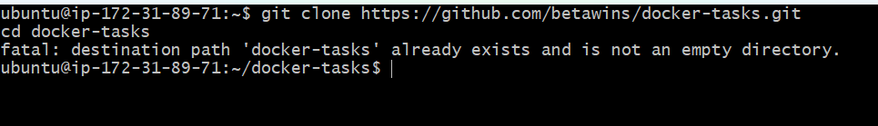

Step 2: Go into Node app directory (where package.json exists).
Cd NodeJs_based_source/
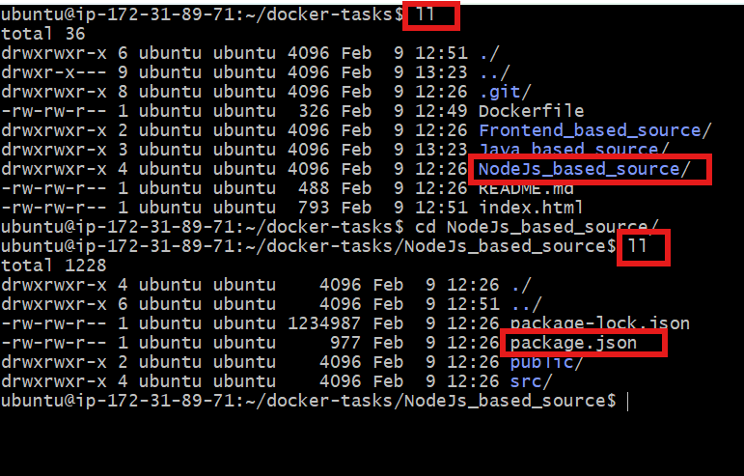

Step 3: Create Dockerfile
Vi DockerFile

FROM node:18-alpine

# create app directory
WORKDIR /app

# copy dependency files first (cache optimization)
COPY package*.json ./

# install dependencies
RUN npm install

# copy remaining source code
COPY . .

EXPOSE 3000

CMD ["npm", "start"]

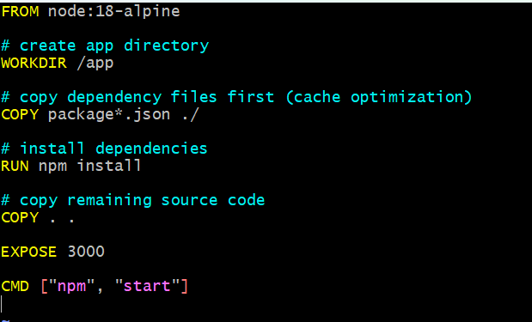

Why copy package.json first?
Docker layer caching → faster builds

Step 4: Build image (tag v1)
docker build -t devops0509/node-app:v1 .
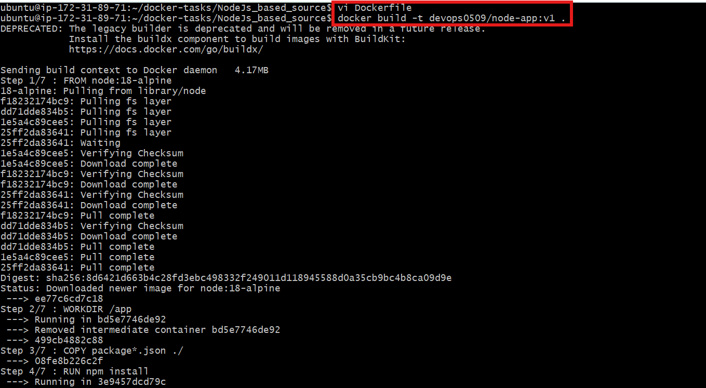
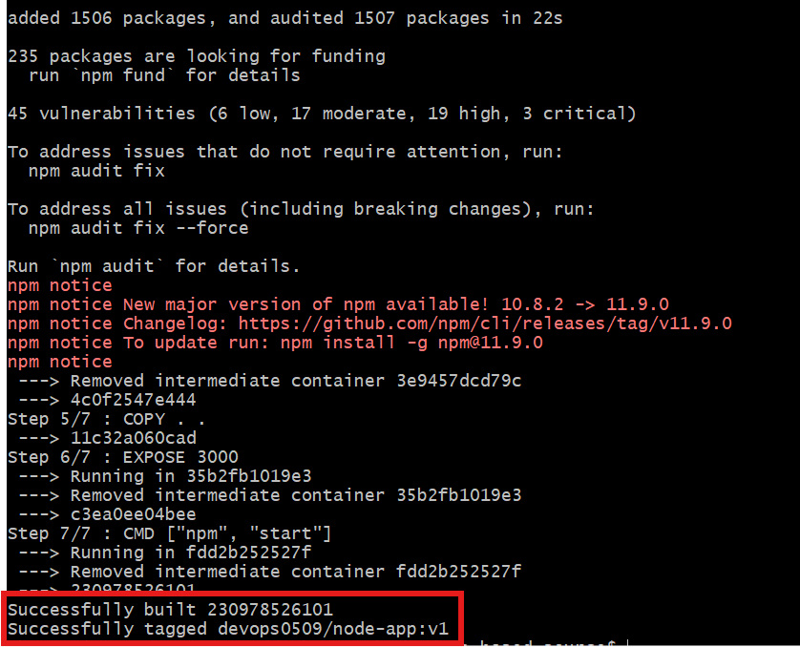

Step 5: Run container
docker run -d -p 3000:3000 devops0509/node-app:v1

Step 5 – Verify
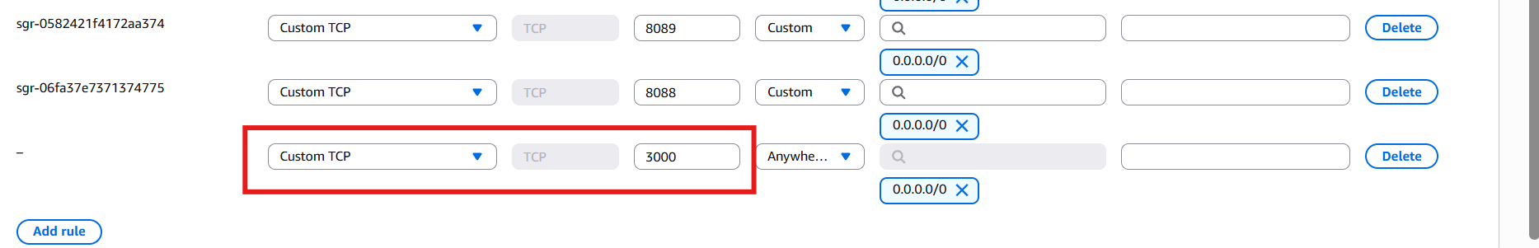



Task 9 - Write a docker-compose file to set up WordPress with a MySQL database.
Objective: Running WordPress + MySQL with Docker Compose is a classic DevOps lab and very close to real hosting setups.
We will run:
- WordPress → web application
- MySQL → backend database
Both containers will talk over a private Docker network.

Step by step Implementation
Step 1: Browser → WordPress → MySQL

Project structure:
wordpress-compose/
└── docker-compose.yml

Step 2: vi docker-compose.yml

version: "3.9"

services:

db:
image: mysql:8.0
container_name: mysql-db
restart: always
environment:
MYSQL_DATABASE: wordpress
MYSQL_USER: wpuser
MYSQL_PASSWORD: wppass
MYSQL_ROOT_PASSWORD: rootpass
volumes:
- db_data:/var/lib/mysql

wordpress:
image: wordpress:latest
container_name: wordpress-app
restart: always
ports:
- "3306:80"
environment:
WORDPRESS_DB_HOST: db:3306
WORDPRESS_DB_USER: wpuser
WORDPRESS_DB_PASSWORD: wppass
WORDPRESS_DB_NAME: wordpress
depends_on:
- db
volumes:
- wp_data:/var/www/html

volumes:
db_data:
wp_data:
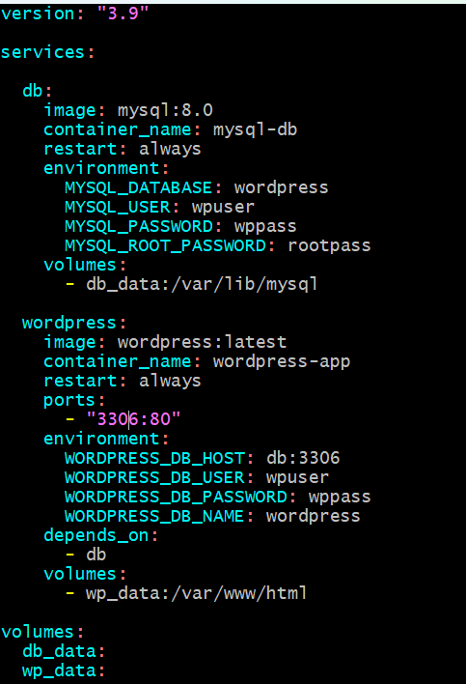

Step 3 – Start containers
docker-compose up -d
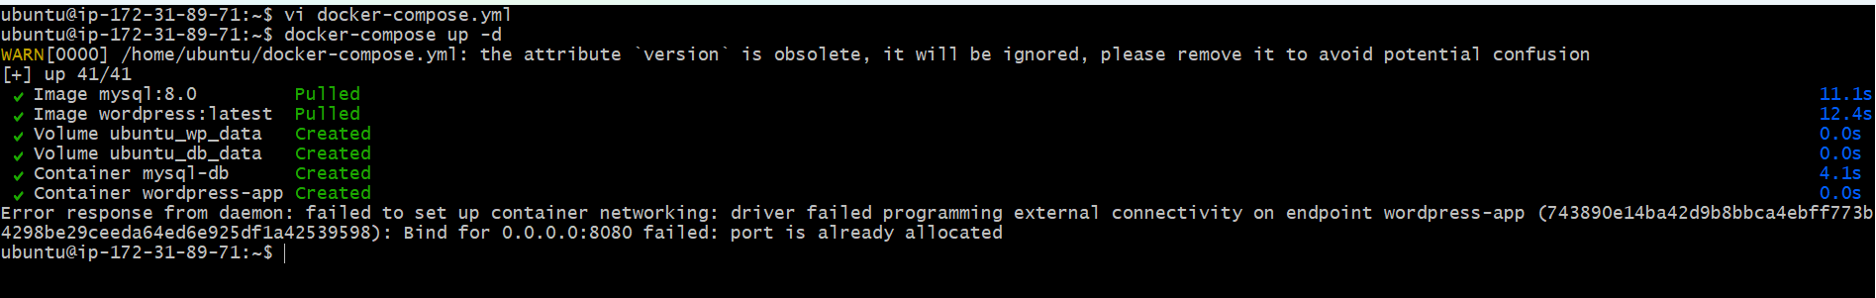

Step 4– Check running
Docker ps
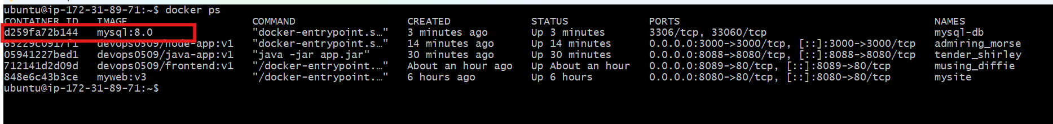
Step 5: Open browser
